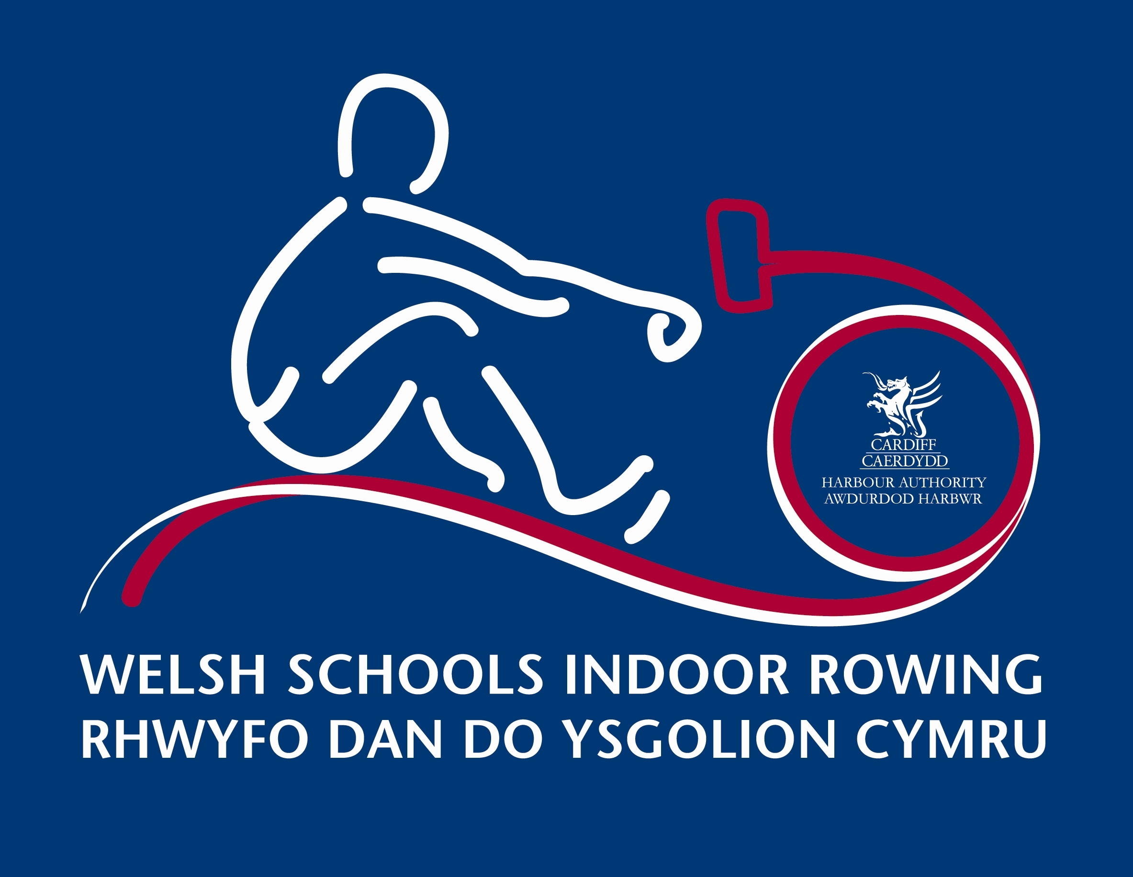
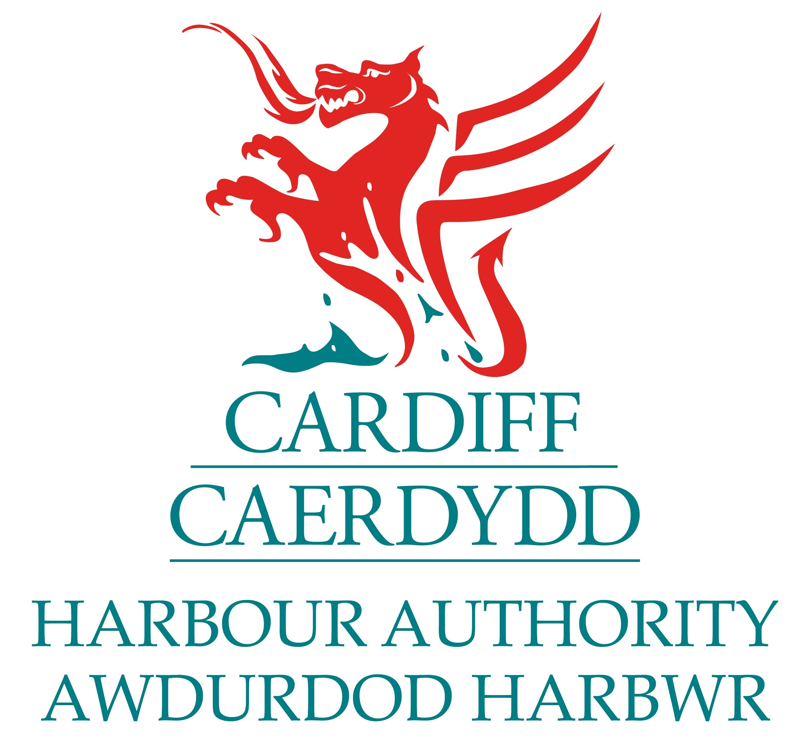

Welsh Schools Indoor Rowing Championships
Friday 30th November 2012
Channel View Leisure Centre, Grangetown, Cardiff, CF11 7HB

Entry Fees: £4.00 Individual events, Team events £8.00 per team
JUNIOR BOYS CATEGORIES
Event No. | Event Title | Time | Distance | School Year
1 | Men’s Junior 12 | 2mins |  | Year 7
2 | MJ13 | 3mins |  | Year 8
3 | MJ14 | 4mins |  | Year 9
4 | MJ15 | 5mins |  | Year 10
5 | MJ16 |  | 2,000 metres | Year 11
6 | MJ17 |  | 2,000 metres | Year 12
7 | MJ18 |  | 2,000 metres | Year 13
JUNIOR GIRLS CATEGORIES
Event No. | Event Title | Time | Distance | School Year
8 | Women’s Junior 12 | 2mins |  | Year 7
9 | WJ13 | 3mins |  | Year 8
10 | WJ14 | 4mins |  | Year 9
11 | WJ15 | 5mins |  | Year 10
12 | WJ16 |  | 2,000 metres | Year 11
13 | WJ17 |  | 2,000 metres | Year 12
14 | WJ18 |  | 2,000 metres | Year 13
TEAM COMPETITIONS
Event No. | Event Title | Time | Distance | School Year
15 | Men’s Junior Team 12 | 4mins |  | Year 7
16 | MJT13 | 4mins |  | Year 8
17 | MJT14 | 4mins |  | Year 9
18 | MJT15 | 4mins |  | Year 10
19 | MJT16 | 4mins |  | Year 11
20 | Women’s Junior Team 12 | 4mins |  | Year 7
21 | WJT13 | 4mins |  | Year 8
22 | WJT14 | 4mins |  | Year 9
23 | WJT15 | 4mins |  | Year 10
24 | WJT16 | 4mins |  | Year 11
ENTRY FORM

First Name: Gender:

Surname: School :

Address: Postcode:

School: Daytime phone no:

Contact e-mail address:
 |  | Event Number | Event Title
INDIVIDUAL EVENTS | £4.00 per entry
TEAM EVENTS | £8.00 per entry
Please write your entry details in CLEAR BLOCK CAPITALS in the spaces provided above.

Closing date for entries: Sunday 25th November 2012
Please include a large SAE and your cheque (cheque no: )
Made payable to ‘CARDIFF COUNTY COUNCIL’ with your entry and send to:
Mike Hnatiw, Championship Entries, Cardiff Bay Water Activity Centre,
Channel View Centre, Jim Driscoll Way, Cardiff Bay, CF11 7HB
Tel: 02920 353912 (office)

CHAMPIONSHIP TERMS & CONDITIONS
1. Entries must be made on an official entry form. Photocopies will be accepted. No pre-event qualification is required – all entries completed correctly and received before the closing date will be eligible to race.

2. Entries should be returned to: Mike Hnatiw, Championship Entries, Cardiff Bay Water Activity Centre, Cardiff Bay, CF11 7HB, to arrive no later than Sunday 25th November 2012. Proof of posting is not proof of delivery and no responsibility will be accepted for entries lost or delayed in the post. Cheques should be made payable to Cardiff County Council. Please clearly write the individual or School name that the payment refers to on the reverse side of the payment cheque(s).

3. Entries not made in accordance to the rules will not be accepted. All details specified on the entry form are required for a valid entry. To avoid disappointment and in order to clarify any entry details please ensure you include a daytime telephone number. Incomplete or illegible entries will not be accepted.

4. Entry fees are non- refundable.

5. By entering the competition, a competitor agrees to be bound by the rules.

6. The Championship Organising Committee reserves the right to limit the size of entry.

7. Concept 2 Indoor Rowers will be used. Competitors may use the resistance of their choice, but this cannot be changed during the race.

8. Races will be held over the British Rowing recognised race distances of two minutes for Year 7s, three minutes for Year 8s, four minutes for Year 9s and five minutes for Year 10s. However, those in Year 11 or above will compete over 2,000m. All Team Category races will be held over a time of 4 minutes.

9. Team Category events require athletes to compete in all-male, or all-female teams of four. Mixed teams, will have to race in Boy’s Category.

10. The decision of the judges is final and no correspondence will be entered into.

11. IMPORTANT - For all competitors the school year will apply; i.e:
J12 = Yr 7 aged under 12 on Aug 31 2012, J13 = Yr 8 aged under 13 on Aug 31 2012,
J14 = Yr 9 aged under 14 on Aug 31 2012, J15 = Yr 10 aged under 15 on Aug 31 2012,
J16 = Yr 11 aged under 16 on Aug 31 2012, J17 = Yr 12 aged under 17 on Aug 31 2012,
J18 = Yr 13 aged under 18 on Aug 31 2012.

12. Minimum age for competitors, on race day, is 10 years old.

13. All entry instructions form part of the rules.

14. All category races will be straight finals, i.e. each competitor will only row once. Some categories might involve several races. The times from all the races for a single category will be ranked to give an overall listing.

15. If a competitor misses his/her race for whatever reason he/she will not be able to re-schedule.

16. No competitor will be allowed to change event on the day of racing. A confirmation of which event a competitor has been entered in will be sent to all entrants. Any mistakes should be notified as soon as possible before race day. On race day, if a mistake is discovered that renders the competitor(s) ineligible to row in the category for which they had been entered, the competitor(s) will no longer be able to race.

17. Gold, silver and bronze medals will be awarded to the overall 1st, 2nd and 3rd competitors in each race category where three or more competitors have raced.

18. Parents and Guardians agree that any photographs taken of their sons/daughters may be used in publications and web images authorised by Cardiff Harbour Authority / Cardiff County Council.

IMPORTANT: Medical Recommendation. If on race day you feel unwell, or have recently been suffering from a virus, we recommend that you do not race. Indoor rowing races require maximal effort and the events organisers take no responsibility for illness or injury caused as a consequence. If you have any doubts, you should seek medical advice prior to racing.
DECLARATION: I have read and understood the terms and conditions and I agree that I will be competing entirely at my own risk

Signed: Name: Date:

